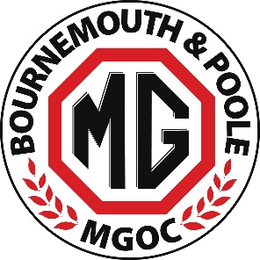
Athelhampton House Garden Party & Picnic - Sunday 10 August 2025
ENTRY FORM
(If handwriting please write clearly in block capitals)

NAME - DRIVER:_________________________________________________________________________

NAME - PASSENGER/S:____________________________________________________________________

Any affiliation to a local MG club or other car club:_____________________________________________

VEHICLE MODEL:_________________________________ REGISTRATION:_________________________

MOBILE PHONE: _________________________________________________________________________

EMAIL: _________________________________________________________________________________
Advance Booking Payment - £12 per person
(includes entry to event & gardens, designated parking and discounted admission to House)
Advance booking fees can be paid by cash or via credit card at a 1020 club night
or via BACS To: Account Name - Bournemouth & Poole MG Owners Club
Account Number - 88130398 / Sort Code - 51-81-41

Paying by BACS - CLEARLY MARK YOUR PAYMENT WITH YOUR NAME & THE WORD ‘ATHEL’
Total Paid £________________Method Paid (Cash / Credit Card or BACS) _______________
- Those booking advance tickets will receive a vehicle pass via email prior to the day
PLEASE RETURN THIS FORM BY FRIDAY 01 AUGUST 2025 TO
Adrian Mullins by hand or via Email: adrianmullinsmgb@gmail.com
Or via post to: 43 Forest View Road, Bournemouth Dorset BH9 3BH

